Test Case: runTestMultipleTimes
Step 1 - Enter username and password and click to button Enter : Credentials Entered
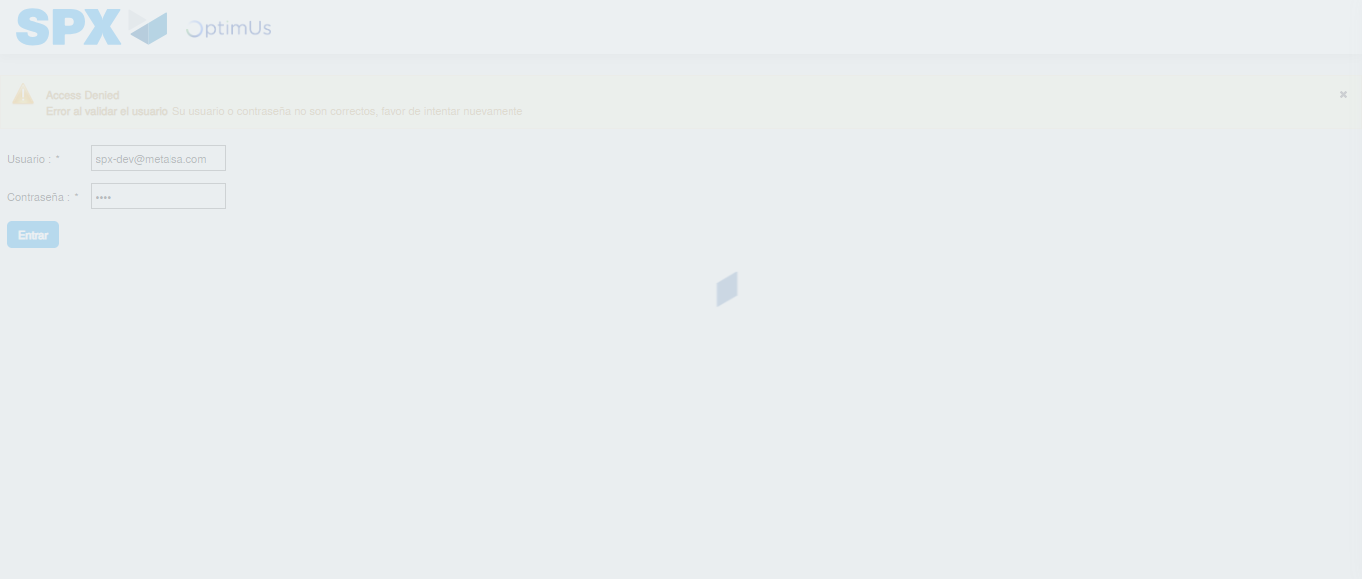Image file-name: QC_Testing-runTestMultipleTimes-dic. 03 2025, 09 29 13 a. m.

Step 2 - Select to UEN and Access to Administrador Roles Menu: UEN Correctly selected and Correct access
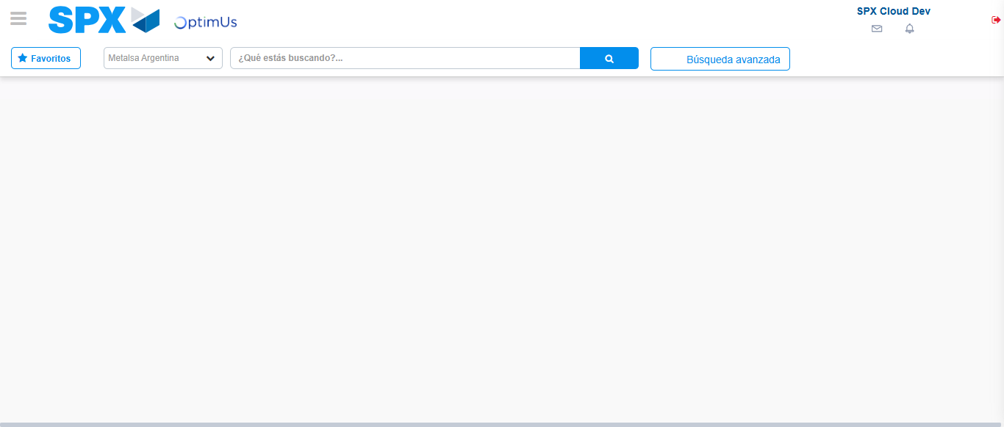Image file-name: QC_Testing-runTestMultipleTimes-dic. 03 2025, 09 29 16 a. m.

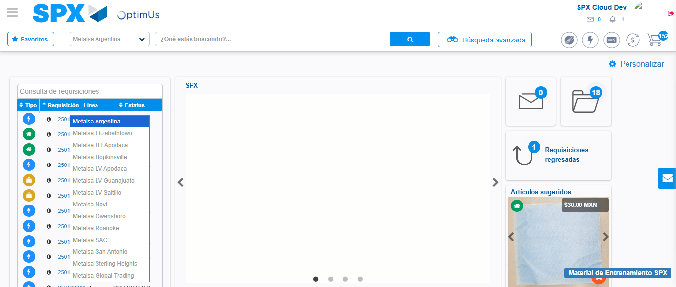Image file-name: QC_Testing-runTestMultipleTimes-dic. 03 2025, 09 29 17 a. m.

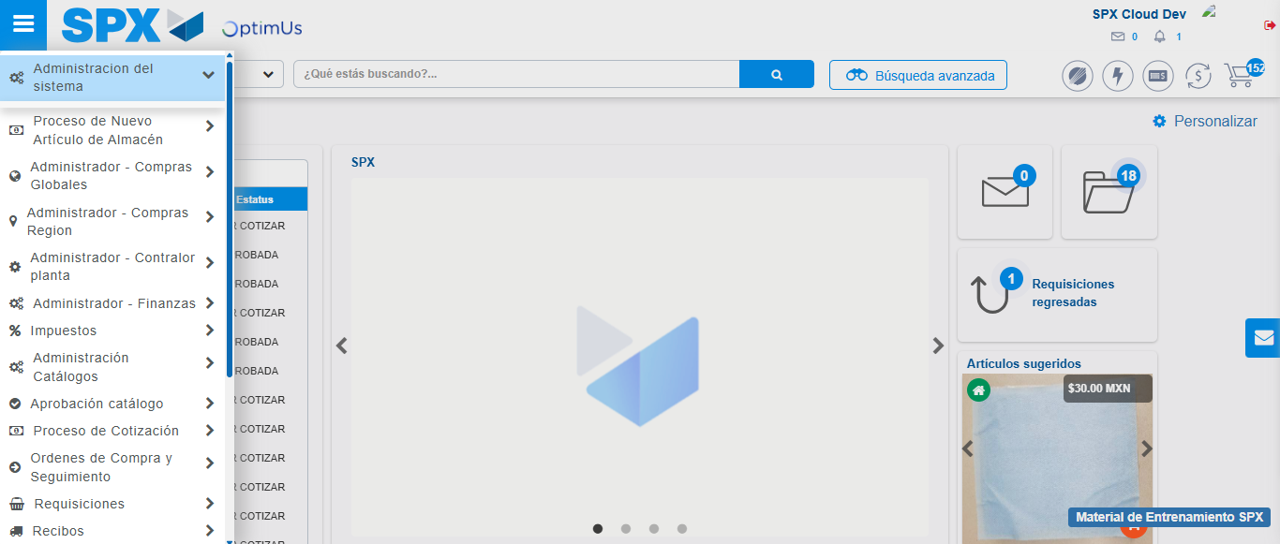Image file-name: QC_Testing-runTestMultipleTimes-dic. 03 2025, 09 29 18 a. m.

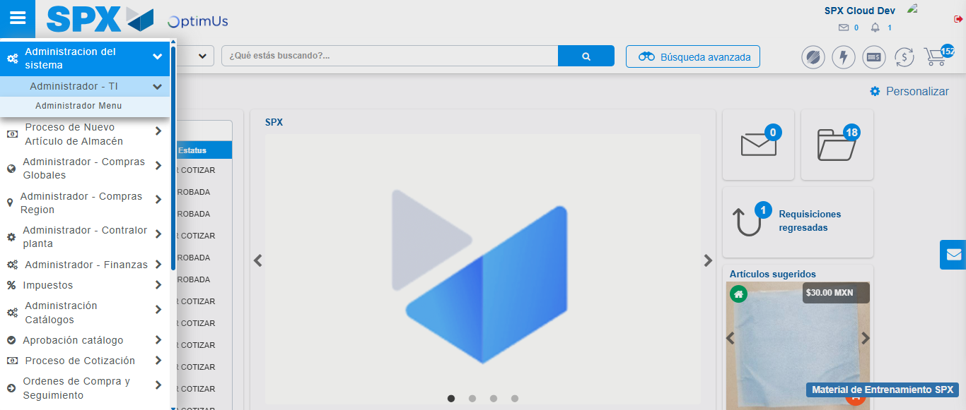Image file-name: QC_Testing-runTestMultipleTimes-dic. 03 2025, 09 29 19 a. m.

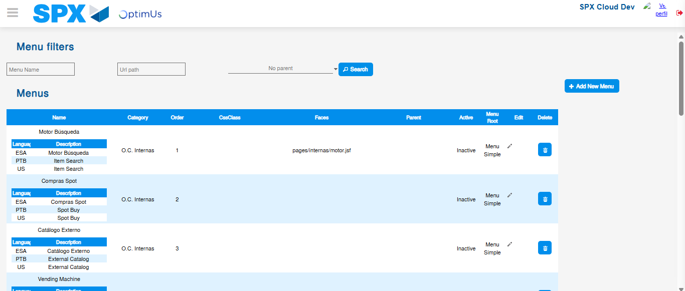Image file-name: QC_Testing-runTestMultipleTimes-dic. 03 2025, 09 29 20 a. m.

Step 3 - Delete record: Record successfully deleted
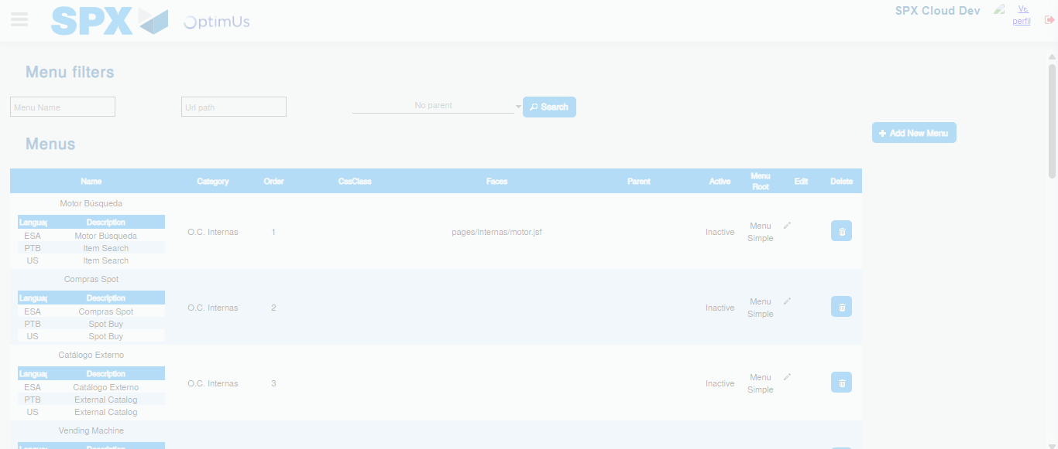Image file-name: QC_Testing-runTestMultipleTimes-dic. 03 2025, 09 29 21 a. m.

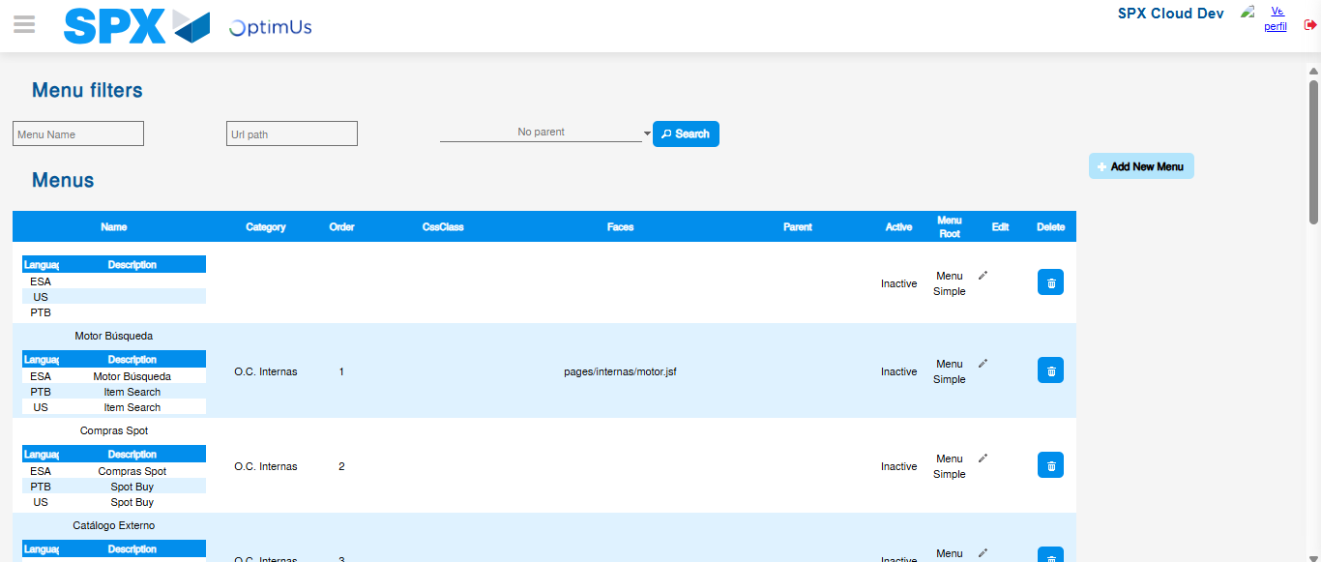Image file-name: QC_Testing-runTestMultipleTimes-dic. 03 2025, 09 29 24 a. m.

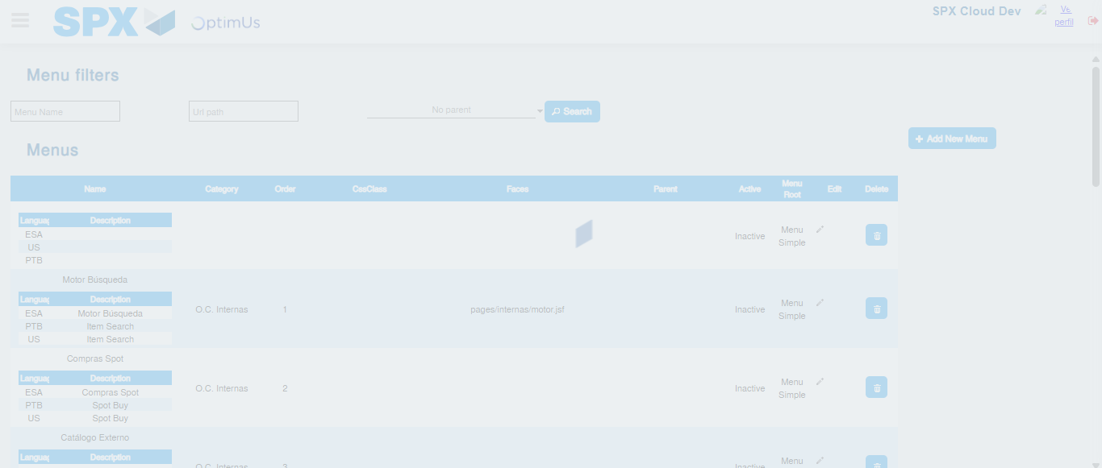Image file-name: QC_Testing-runTestMultipleTimes-dic. 03 2025, 09 29 25 a. m.

